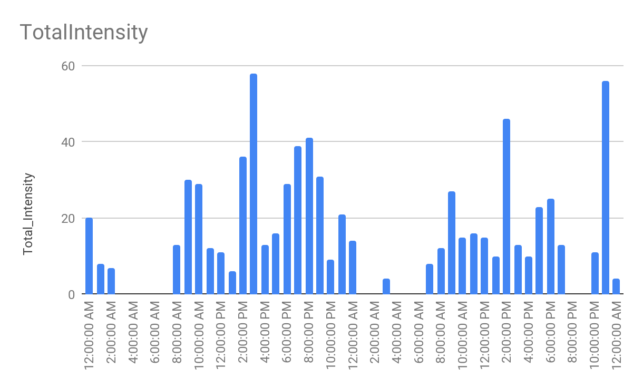

* The highest intensity trend is between 2:00-3:00 PM and 10:00 PM-12:00 AM. The lowest intensity Trend is between 2:00 AM-4:00 AM. But Not any activity is between 3:00 AM-7:00 AM.
* The highest calories burn between 8000-9000
* The graph follows the main trends that during the early morning, afternoons and at nights, those are the times when the amount of calories, which is probably being measured for intensity, burned were at their highest which makes sense because the human body naturally burns around 2000 calories while at sleep/rest. Along with that, most of the most calories are burned in the afternoon, namely at 2 PM, and it takes a big dip after that which probably makes sense because many people take that time to rest their body and that is when their daily activity is at its lowest.

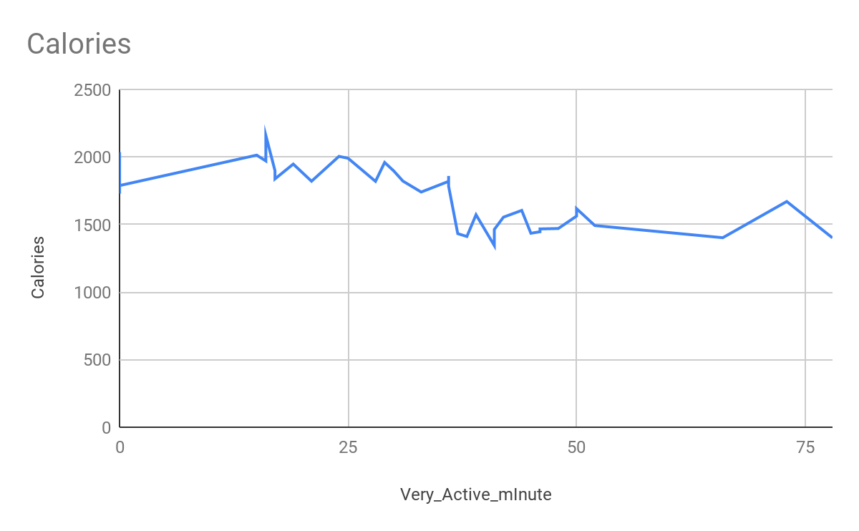

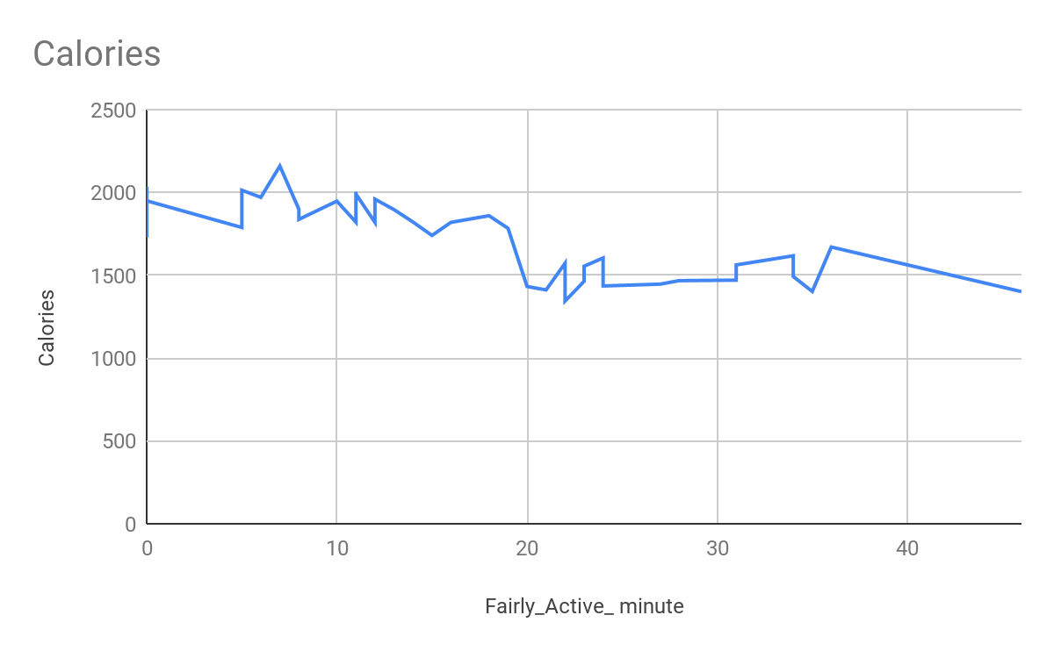

* This graph is showing us that while the body is in a very active motion, the calories burned are at their highest at the beginning of the very active movement, but over time, the amount of calories burned goes down.
* This is probably reasonable because, for example, in a workout, when you start your movement, you body has the most amount of energy, so you're able to burn more calories that time, however, as you keep being active, you run out of energy, and since you already used up a lot of calories, it makes sense you don't have much to use in the end anymore.

| *Steps01* | AVERAGE of Steps01 | SUM of Steps01 | MAX of Steps01 | MIN of Steps01 |
| --- | --- | --- | --- | --- |
| 0 | 0 | 0 | 0 | 0 |
| 7 | 7 | 7 | 7 | 7 |
| 11 | 11 | 11 | 11 | 11 |
| 14 | 14 | 14 | 14 | 14 |
| 15 | 15 | 15 | 15 | 15 |
| 16 | 16 | 16 | 16 | 16 |
| 30 | 30 | 30 | 30 | 30 |
| 113 | 113 | 113 | 113 | 113 |
| 132 | 132 | 132 | 132 | 132 |
| **Grand Total** | **6.897959184** | **338** | **132** | **0** |

| *ActivityHour* | SUM of TotalIntensity | SUM of AverageIntensity | COUNTA of Hourly Activity |
| --- | --- | --- | --- |
| 4/12/2016 0:00:00 | 20 | 0.33 | 1 |
| 4/12/2016 1:00:00 | 8 | 0.13 | 1 |
| 4/12/2016 2:00:00 | 7 | 0.12 | 1 |
| 4/12/2016 3:00:00 | 0 | 0.00 | 1 |
| 4/12/2016 4:00:00 | 0 | 0.00 | 1 |
| 4/12/2016 5:00:00 | 0 | 0.00 | 1 |
| 4/12/2016 6:00:00 | 0 | 0.00 | 1 |
| 4/12/2016 7:00:00 | 0 | 0.00 | 1 |
| 4/12/2016 8:00:00 | 13 | 0.22 | 1 |
| 4/12/2016 9:00:00 | 30 | 0.50 | 1 |
| 4/12/2016 10:00:00 | 29 | 0.48 | 1 |
| 4/12/2016 11:00:00 | 12 | 0.20 | 1 |
| 4/12/2016 12:00:00 | 11 | 0.18 | 1 |
| 4/12/2016 13:00:00 | 6 | 0.10 | 1 |
| 4/12/2016 14:00:00 | 36 | 0.60 | 1 |
| 4/12/2016 15:00:00 | 58 | 0.97 | 1 |
| 4/12/2016 16:00:00 | 13 | 0.22 | 1 |
| 4/12/2016 17:00:00 | 16 | 0.27 | 1 |
| 4/12/2016 18:00:00 | 29 | 0.48 | 1 |
| 4/12/2016 19:00:00 | 39 | 0.65 | 1 |
| 4/12/2016 20:00:00 | 41 | 0.68 | 1 |
| 4/12/2016 21:00:00 | 31 | 0.52 | 1 |
| 4/12/2016 22:00:00 | 9 | 0.15 | 1 |
| 4/12/2016 23:00:00 | 21 | 0.35 | 1 |
| 4/13/2016 0:00:00 | 14 | 0.23 | 1 |
| 4/13/2016 1:00:00 | 0 | 0.00 | 1 |
| 4/13/2016 2:00:00 | 0 | 0.00 | 1 |
| 4/13/2016 3:00:00 | 4 | 0.07 | 1 |
| 4/13/2016 4:00:00 | 0 | 0.00 | 1 |
| 4/13/2016 5:00:00 | 0 | 0.00 | 1 |
| 4/13/2016 6:00:00 | 0 | 0.00 | 1 |
| 4/13/2016 7:00:00 | 8 | 0.13 | 1 |
| 4/13/2016 8:00:00 | 12 | 0.20 | 1 |
| 4/13/2016 9:00:00 | 27 | 0.45 | 1 |
| 4/13/2016 10:00:00 | 15 | 0.25 | 1 |
| 4/13/2016 11:00:00 | 16 | 0.27 | 1 |
| 4/13/2016 12:00:00 | 15 | 0.25 | 1 |
| 4/13/2016 13:00:00 | 10 | 0.17 | 1 |
| 4/13/2016 14:00:00 | 46 | 0.77 | 1 |
| 4/13/2016 15:00:00 | 13 | 0.22 | 1 |
| 4/13/2016 16:00:00 | 10 | 0.17 | 1 |
| 4/13/2016 17:00:00 | 23 | 0.38 | 1 |
| 4/13/2016 18:00:00 | 25 | 0.42 | 1 |
| 4/13/2016 19:00:00 | 13 | 0.22 | 1 |
| 4/13/2016 20:00:00 | 0 | 0.00 | 1 |
| 4/13/2016 21:00:00 | 0 | 0.00 | 1 |
| 4/13/2016 22:00:00 | 11 | 0.18 | 1 |
| 4/13/2016 23:00:00 | 56 | 0.93 | 1 |
| 4/14/2016 0:00:00 | 4 | 0.07 | 1 |
| **Grand Total** | **751** | **12.52** | **49** |